Company Profile
NIHVA Technologies Pvt. Ltd.

- Name of the Company | NIHVA Technologies Pvt. Ltd.
- Location | 187, G-Block, Thermax Chowk,  MIDC Chinchwad, Pune - 411019
- Contact | +91 8551091333
- Email Id. | sales@nihva.com
- Website | https://www.nihva.com
- Founder and director | Mr. Vijay M Tarak
Introduction:

About Us:-
“NIHVA” pioneers in offering intelligent, innovative and economical ‘Solutions’. We are proud of our products and service range offered with a high level of working safety, comfort, functionality and supported by value added solutions & services.
“NIHVA” specializes in providing integrated solutions in Door automation, customized material handling solutions, factory and warehouse automation, Roof and Window automation, Mobile warehouses Apart from this , for any project our scope commences from under-standing the requirement, functionality, designing & solution to installation and commissioning. Further we prefer to be with you by providing a service backup for a ‘commitment beyond contract’.
We understand the importance of manpower in providing such services to our esteemed customers and therefore we have best Technician, Engineers to ensure trouble free services. Our values and culture drive team empowerment and trusted customer relationships. Our business partners / associates are global market leaders & specialize in application knowledge. The combination of this knowledge & our expertise allows us to appreciate unique business challenge and to support you with the most efficient solution. Our head office is located at Pune in Maharashtra (India). “NIHVA” has always been strongly supported by world leaders in automation. Our commitment is to execute projects with highest quality, on time & within the budget, while adhering to safety, health and environmental standards and to get established as an icon in providing best engineering services.
NIHVA’s commitment to quality and innovation has earned them a reputation as one of the leading automation solutions providers in India. They are a trusted partner for businesses of all sizes who are looking to improve their operations. (In the Boxes)

“NIHVA” has always been strongly supported by world leaders in automation brands.
- Vision
We will be the most valued business partner of our customers
- Mission
We provide intelligent and innovative engineering solutions and services that meet the need of all our customers
- Core Values
Driven by Positive Approach, Attitude & Accountability. Accelerate always Respect, Relations & Results. Continuous Improvement in - Change, Communication, Gratitude, Performance & Leadership Satisfaction and Happiness at the end of every day.
- Core Purpose
Inspire the individuals and organizations by offering Innovative Solutions, Products and Services that enrich people’s lives, save their Efforts, Time, Money and contribute to social prosperity by creating a new future.
Product line:-

Our Products:
Inside Plant Doors :-
Inside Plant doors that are designed with the latest technology is extremely secure, reliable and safe High-speed Doors for interior gateway applications. Interior roll-up doors ensure easy installation, improve facility efficiency and separate the unfavourable areas. Roll up interior doors are also used in cold storage environments as cold room doors and in the pharmaceutical industry and cleanrooms as clean room doors for maintaining the interior environment.
These doors have fast opening speeds, high-quality safety systems, and need very little service & maintenance. Have tight sealing and are resistant to pressure for controlling the environment. Inside plant high-speed doors are thus designed to be an ideal companion to your door arch, performing reliably and safely around men and equipment. These industrial doors are equipped with high-quality safety instrumentation and provided with safety edge, photocell, radar sensors, and various access control like biometric and RFID based opening.
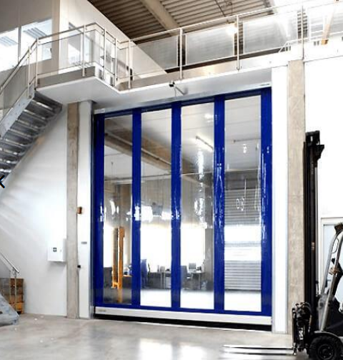
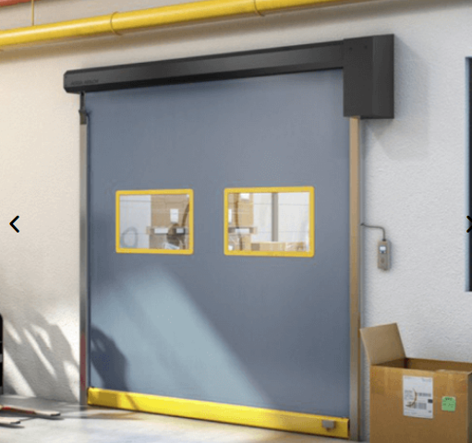

Features Of Inside Plant Doors / High-Speed Doors
- USED FOR INTERIOR APPLICATION
- SPLASH RESISTANT
- EFFICIENT BARRIERS BETWEEN COMPARTMENTS
- REDUCES AIR INFILTRATION
- HIGH SPEED OPERATION FOR REDUCED AIR LEAKAGE
- BOTTOM SAFETY EDGE
- RADAR BASED AUTOMATIC OPERATION
- ACTS AS THERMAL BARRIER
- ACCESS CONTROL – BIOMETRIC, RFID, KEY CARD-BASED, PUSH BUTTON-BASED.

Outside Plant Doors
NIHVA Technology manufactures a wide variety of well performing High-Speed Doors exterior doors with the latest technology that keeps your plants running smoothly. Designed to deliver safety, strength, and smooth functionality, a built-in exterior door manages the flow of equipment, materials, and people moving between your facilities. Ideal for areas with a forklift and heavy equipment traffic, these doors handle large openings with speed, efficiency, reliability, and safety. Metal exterior security doors create a secure, energy-efficient entrance for your facility, and are extremely easy to install. These High-Speed Doors provide resistance against wind, rain, and harsh weather.

Features Of Outside Plant Doors
- USED FOR OUTSIDE PLANT APPLICATIONS
- PROTECTION AGAINST WEATHER AND WIND
- BUTTON/REMOTE OPERATED
- HIGH-SPEED OPERATION FOR REDUCED AIR LEAKAGE
- BOTTOM SAFETY EDGE
- BUTTON/REMOTE OPERATED
- RADAR BASED AUTOMATIC OPERATION
- ACTS AS THERMAL BARRIER
- THICK CURTAIN MATERIAL – LONG-LASTING
- VISION PANELS AVAILABLE
- PASS DOOR OPTION AVAILABLE WITH A HIGH-SPEED DOOR
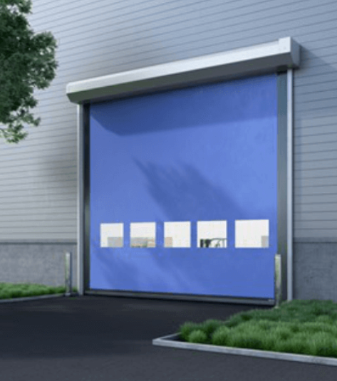

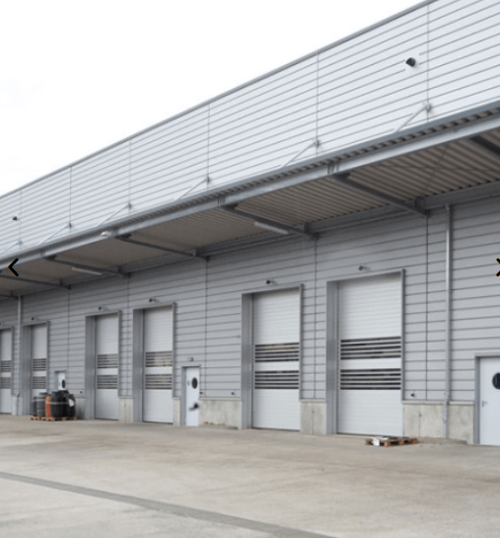

Machine protection door
NIHVA machine protection door forms an important component of a machining setup, be it a robotic cell or a conveyor-based assembly line. Door solutions provided by NIHVA ensures easy installation and protects the machine from the external environment, safeguards the operator, and the other components from machine-related hazards. Their major functions are improved operator safety from hazards like robot strike, arc flash, weld spatters, metallic burr, noise, coolant splashes, etc.
Features Of Machine Protection Door
- Protects Machine From The Environment
- Protects Environment And Operator From The Machine
- Reduces Chances Of An Accident
- High-Speed Operation
- High Speed Operation For Reduced Air Leakage
- Suitable For High-Efficiency Assembly Line
- Equipped With Various Sensors To Cope Up With The Dynamic Manufacturing Process

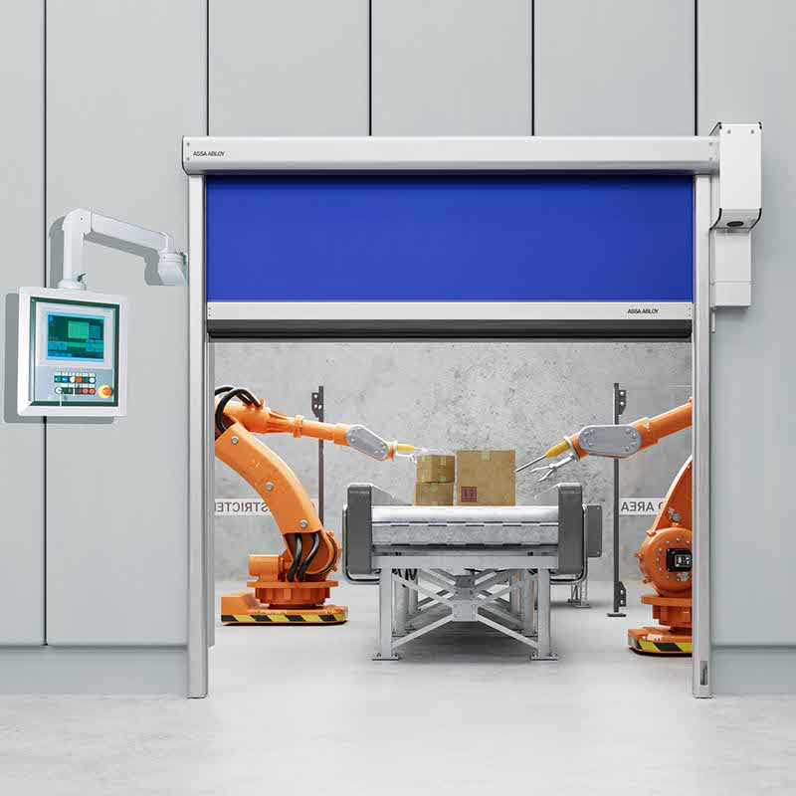

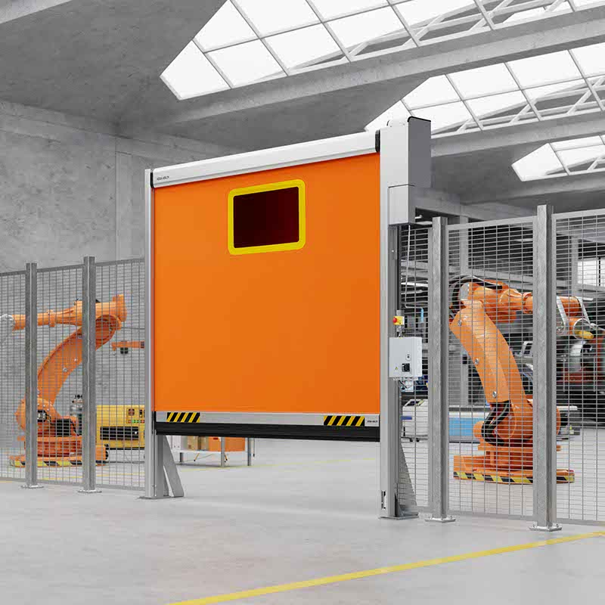
Pharma and Clean Room Industries Doors
NIHVA Technologies manufactures Pharma Doors or cleanroom doors for industrial purposes that are specially designed to cater to the requirements of cleanrooms, pharmaceutical industries, or any other industry where particular matter infiltration needs to be arrested. Industries such as pharmaceuticals, micro-mechanic, electronics, and chemicals demand high-quality high-speed doors. The doors contain airtight sealing to reduce pressure and safeguard the environment from dust, dirt, and humidity.
These specifications require uniquely designed doors. NIHVA provides cleanroom doors that are perfect for such applications, ensures easy installation, and meets the highest quality standards.
Features Of Cleanroom Door
- REDUCES AIR INFILTRATION
- SPECIALLY DESIGNED CURTAINS FOR THERMAL INSULATION
- BOTTOM SAFETY EDGE
- BOTTOM RUBBER PROFILE FOR SEALING
- REDUCES CHANCES OF EXTERNAL BIOLOGICAL CONTAMINATION.
- RADAR-BASED AUTOMATIC OPERATION
- SPECIALIZED ROLLTEX CURTAIN FOR REDUCED PARTICLE EMISSIO
- HIGH-SPEED APPLICATION
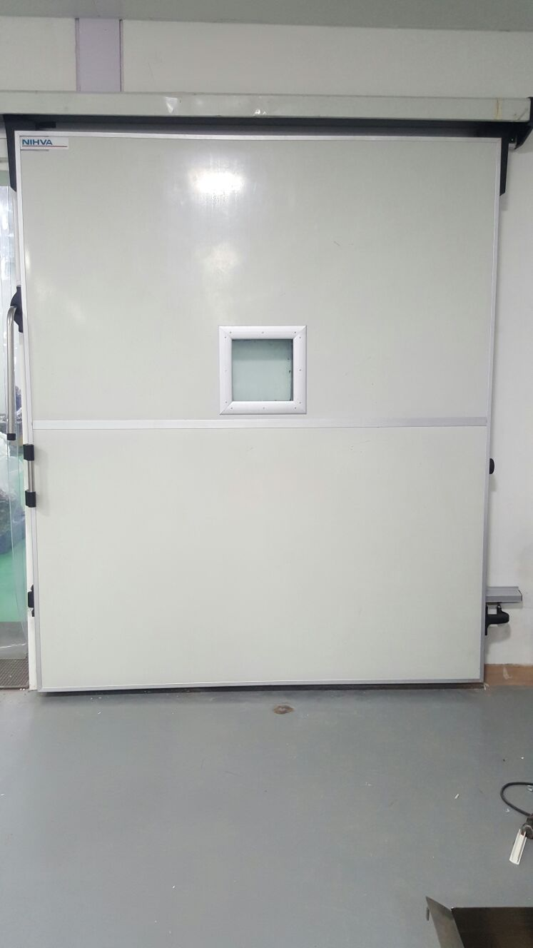

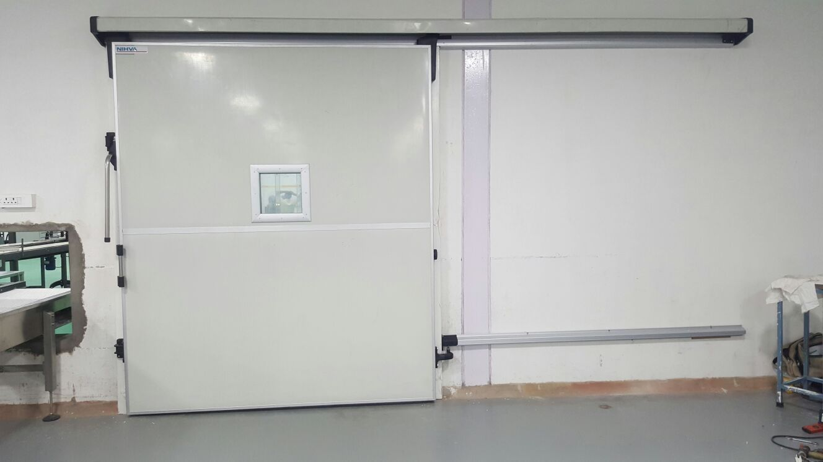
Food Industries Doors
NIHVA Technologies is the leading industrial High-speed door manufacturer meeting stringent quality standards with the highest operational speed and more cycles per hour. NIHVA doors are widely used in various food and beverage industries.
The food and beverage industry has to maintain a very high hygiene standard. The slightest infiltration of outside dust can completely damage the product. At NIHVA, we provide food industry doors to suit these specific industry demands. We provide food industry doors from the ASSA ABLOY Rapid Roll series.
Features Of Food Industries Door:
- HIGH-SPEED OPERATION
- LIMITED AIR INFILTRATION
- LOW OPERATING COST
- WINDOWS/VISION PANELS AVAILABLE FOR CURTAINS
- INSULATED CURTAINS – FOR TEMPERATURE CONTROL.
- FOOD INDUSTRY HIGH-SPEED DOORS PROVIDED BY NIHVA ARE WIDELY USED IN –
- REFRIGERATED FOOD INDUSTRY
- REFRIGERATED SUPPLY CHAIN – COLD CHIN INDUSTRY

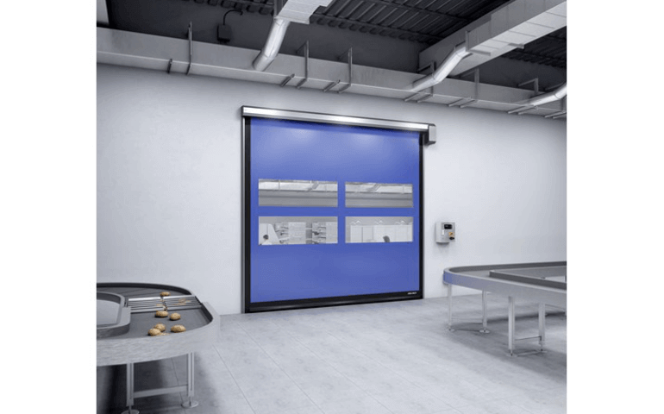
Heavy-Industrial-Doors
Engineered for tough and corrosive conditions of the industry, NIHVA manufactures Heavy Industrial Doors designed for large size openings and intense work environments. NIHVA offers a unique design with durability and operating reliability. Not only do they fit perfectly with the industrial setting, but also offer maximum security and can be customized as per requirement.
These heavy industrial doors are offered with a variety of instrumentations like button-operated opening and closing, high-speed operation, photocells, bottom safety edge, etc. these doors also offer the vision panels and pass doors for ease of access. Integrated with building management systems, these doors are the perfect solution for large openings as they are designed with the latest technology.

Features of Heavy Industrial-Doors:
- CUSTOMIZABLE SIZE
- VARIOUS TYPES OF CURTAIN MATERIALS
- PASS DOOR OPTIONS
- VISION PANEL OPTIONS
- RESISTANT AGAINST THE TOUGH ENVIRONMENT
- SMOOTH AND FAST OPERATION

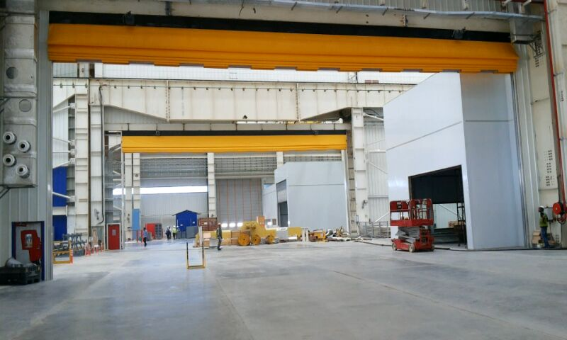
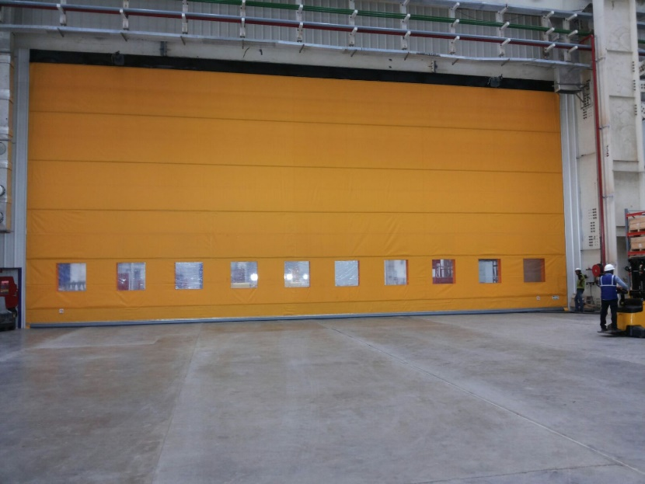
Cold room Doors
Cold room Doors are High-Speed Doors designed keeping in mind the minimization of heat loss across curtains. To maintain the quality of certain products it is essential to store them in cold rooms. NIHVA can meet this requirement of cold storage areas with insulated high-speed cold storage doors and freezer doors. These freezer doors provide reliable thermal barriers essential in protecting the product quality in critical temperature zones. These door solutions enhance temperature control, reduce energy costs and help increase productivity.
The curtain material of these cold room doors – high-speed doors is a specially designed RollTex material, efficient in maintaining the temperature range up to -40 °C. These high-speed doors have their instrumentation panels and other sensors fitted with the additional heating coil, to prevent frost accumulation. This, the control panels keep on working at the sub-zero temperatures of cold rooms.

Features Of Cold Room Doors
- THERMALLY INSULATED CURTAINS
- HIGH-SPEED OPERATION FOR MINIMUM HEAT LOSS
- INSULATED AND SEALED BOTTOM
- SAFETY EDGE
- CONTROL PANEL HEATING FOR OPTIMUM SUB-ZERO PERFORMANCE
- HEATING COIL FOR CONTROL BOX AND PHOTOCELL
- GEARBOX HEATING TO AVOID AIL FREEZING
- SMOOTH AND FAMANUAL OPERATION IN EVENT OF POWER LOSSST OPERATION

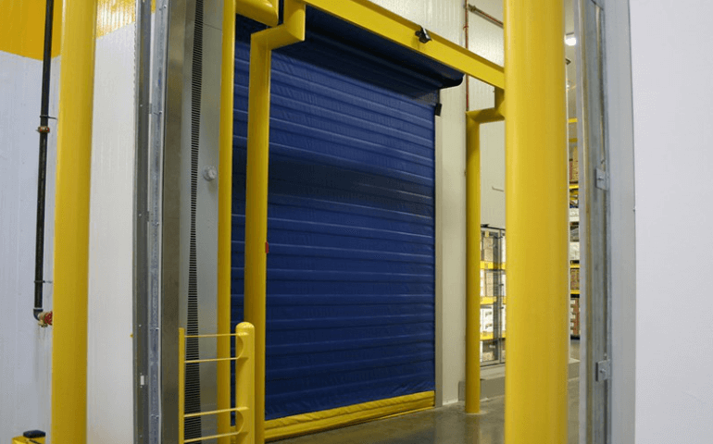
Puf Insulated Doors
Puf insulated doors are special insulated industrial sectional doors that are used for exterior applications. These doors provide adequate protection against external environments and help maintain the internal environment.
We, at NIHVA Technologies, manufacture world-class Sectional Doors of ASSA ABLOY that provide easy installation. These doors maintain optimum work conditions and reduce the overall energy cost. ASSA ABLOY OH1042P from NIHVA gives you an excellent thermal separation with its innovative features such as tight top, side seals, and water-resistant bottom seal. These features ensure the reduction of drafts and condensation at the workplace. The doors are made from Aluminium or GI panels and puf panels inside them. The PU foam is used for thermal separation and insulation purposes.

Features Of Puf Insulated Door
- USED FOR FUNCTIONAL AND AESTHETIC NEEDS
- PROTECTS AGAINST ROUGH WEATHER
- EXTERNAL USE
- USED AT LOADING BAY OR MAIN ENTRANCES
- PASS DOOR – OPTIONAL
- BUTTON/REMOTE OPERATED
- PU FOAM USED AS A THERMAL INSULATING MATERIAL
- RADAR-BASED AUTOMATIC OPERATION
- VISION PANELS AND FULL GLAZING AVAILABLE
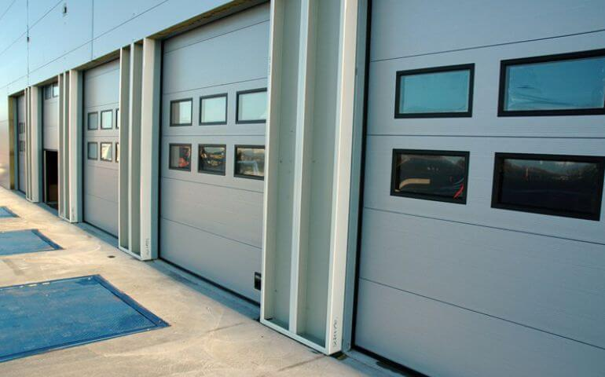

Glazed Overhead Doors
We, at NIHVA Technologies, provide world class Sectional Doors of ASSA ABLOY make. ASSA ABLOY OH1042F from NIHVA gives you an excellent thermal separation with its innovative features such as tight top, side seals and water-resistant bottom seal. These features ensure reduction of drafts and condensation at work place.
These overhead sectional doors give you a good control over interior environment to create and maintain optimum air conditioning that suits the season, with lesser energy consumption. Used in industrial and commercial settings, these doors feature high aesthetic value as well as high functional value. Available in glazing panels, these doors are used for exterior purpose, like in showrooms and shopping malls along with industry.
Features of Our Sectional Doors Are
- USED FOR FUNCTIONAL AND AESTHETIC NEEDS
- PROTECTS AGAINST ROUGH WEATHER
- EXTERNAL USE
- USED AT LOADING BAY OR MAIN ENTRANCES
- PASS DOOR – OPTIONAL
- BUTTON / REMOTE OPERATED
- RADAR BASED AUTOMATIC OPERATION
- VISION PANELS AND FULL GLAZING AVAILABLE
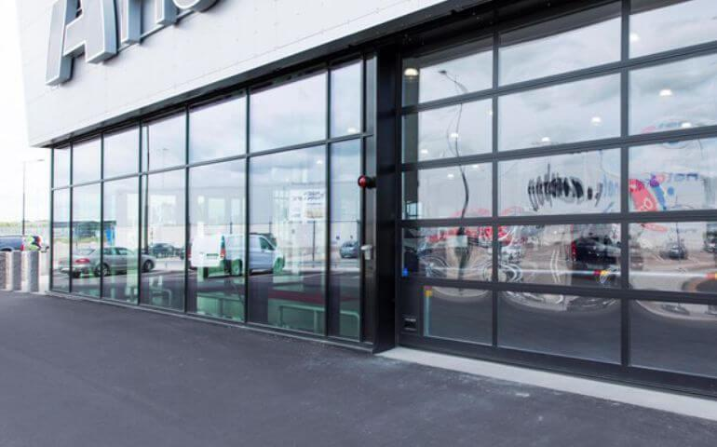

Folding Doors
Folding doors are known for extra energy efficiency in industrial environments. These new highly functional automated folding doors are designed for minimal maintenance. As the doors slide open the lifting hinges raise the door off the floor keeping wear and tear to a minimum. The doors remain always visible as they open and close, so collision risk is reduced to a large extent.
The folding doors are uniquely designed to be lifted off the ground while being under operation. This feature ensures low wear and tear and thus lower maintenance.

Features Of Folding Doors
- Developed As Per Environmental Management System Guidelines
- Provides A Safe Working Environment
- Low Maintenance
- Self-Lifting Arrangement
- Teflon Coated Self-Lubricating Hinges

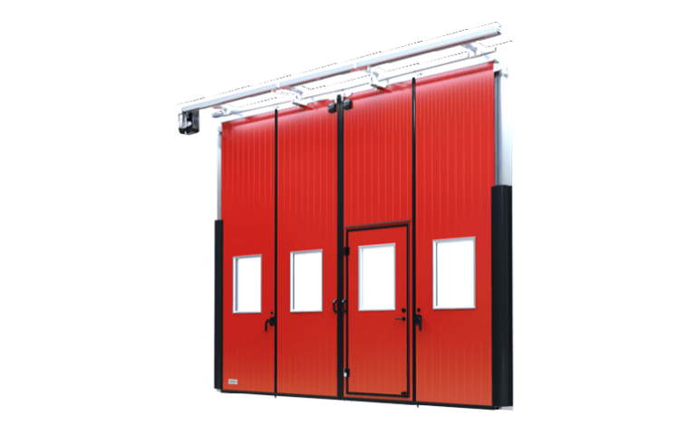

Telescopic Sliding Doors
Telescopic sliding doors find application in the applications that require the maximum utilization of clear space. Telescopic Sliding Doors are manufactured by unique & state of the art fabrication techniques using sturdy frames that allow minimum deflection. A number of doors leafs are decided on the basis of clear opening required and available space. These doors are known to provide maximum clear opening and require very little parking space. Telescopic folding doors need very little parking space, thanks to the telescopic action. Thus, the sliding folding door is an ideal product for hospital entrance doors or shopping mall doors, which handle a large influx of people moving across at any time. Also, to carry a stretcher bed across, more amount of clear space is required. Thus, sliding folding doors finds many applications in the healthcare and retail industry.In the mechanical and logistic industry, the sliding folding door is used as an entry gate for logistic and material handling stations.The maximum clear opening and lesser parking space make it easy for Material Handling Equipment like scissor lifts or forklifts to move through. The excess clear opening is a major advantage of this unique type of doorway solution.
Features Of Telescopic Sliding Doors
- Developed As Per Environmental Management System Guidelines
- Provides A Safe Working Environment
- Low Maintenance
- Self-Lifting Arrangement
- Teflon Coated Self-Lubricating Hinges
- Guides And Channels Made From High-Quality Material For Low Corrosion
- Designed For The High Operating Frequency

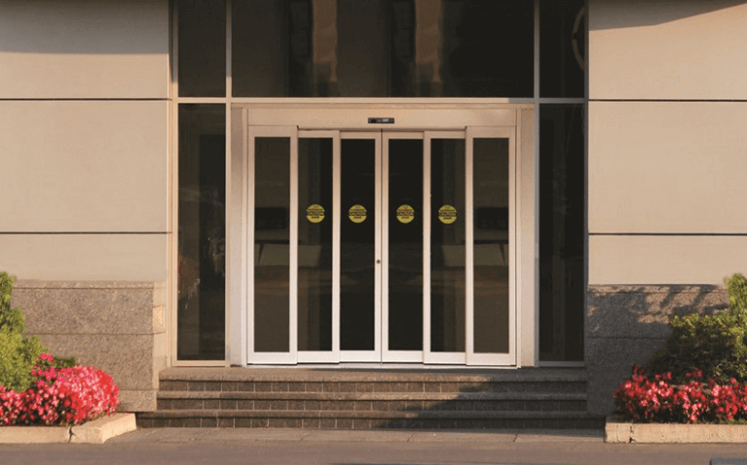

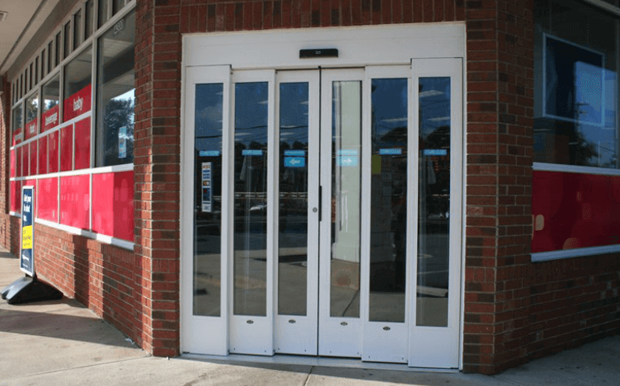

Aviation Hangar Door
Aviation Hangar Doors are usually preferred for the large openings required for the gateways of aircraft housings. This system can be a single door leaf or multiple doors leaf system. The aviation hangar doors have no size limitation and can withstand harsh environments with extra-large openings.
The door fabric of these Hangar Door is specially designed for internal temperature control. The Megadoor fabric, which was originally designed for a harsh industrial environment, is perfect for an application in the aviation industry, providing perfect protection from wind, dust, and the external environment.
Translucent door fabric gives optimum daylight utilization. These hangar doors are thus the best option for an entrance system solution to aircraft hangars.
Aircraft hangar doors are manufactured on the fundamental principles of functional safety and operational reliability. NIHVA Technologies is one of the best manufacturers and suppliers of hangar doors in India that goes the extra mile to achieve stellar functionality.

Features Of Hangar Doors
- ARCHITECTURE & ENGINEERING SUPPORT
- REUSABLE IN TEMPORARY INSTALLATIONS
- ENDURE WIND LOADS AND WITHSTAND STURDY WEATHER CONDITIONS
- MAINTAINS A STEADY WORKING ENVIRONMENT

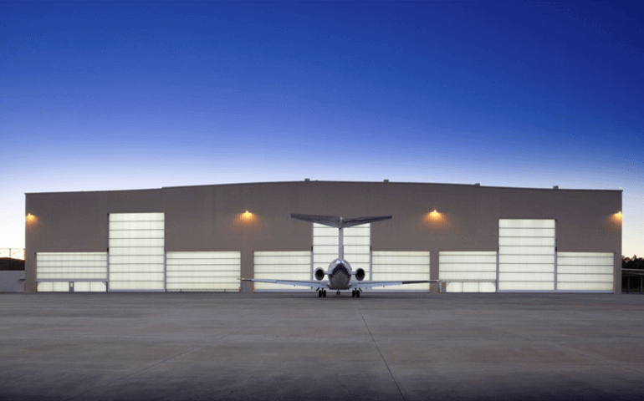

Shipyard Doors
Designed to withstand heavy traffic, high operating frequency, and high mechanical stresses, shipyard doors form a perfect gateway solution to safely house the ships. Shipyard doors form a durable barrier against the coastal environment with high winds and corrosive conditions. With the safe, durable and efficient operation, they meet a large number of logistics demands.
The fabric of shipyard doors is a specialized Megadoor fabric, similar to that of the Hangar door, which is very useful in protecting the ships against mechanical impacts of waves and the corrosive action of the sea.
Features Of Shipyard Doors –
- CORROSION-RESISTANT MATERIAL
- CAN SUSTAIN HARSH ENVIRONMENT
- PROVIDES HIGH-ENERGY EFFICIENCY
- IDEAL FOR LARGE OPENINGS
- TRANSLUCENT MEGADOOR FABRIC FOR DAYLIGHT UTILIZATION
- NO-TRACK SYSTEM – NO FLOOR TRACKS
- MULTI-LEAF DOORS FOR MASSIVE OPENING WIDTHS.
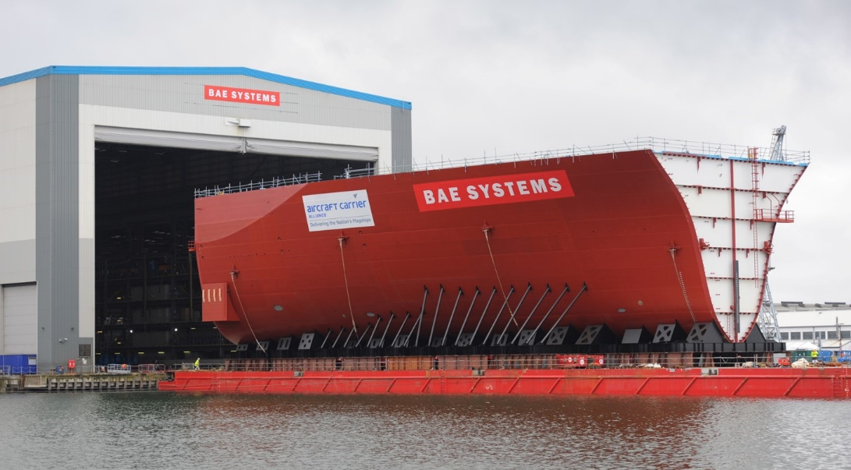

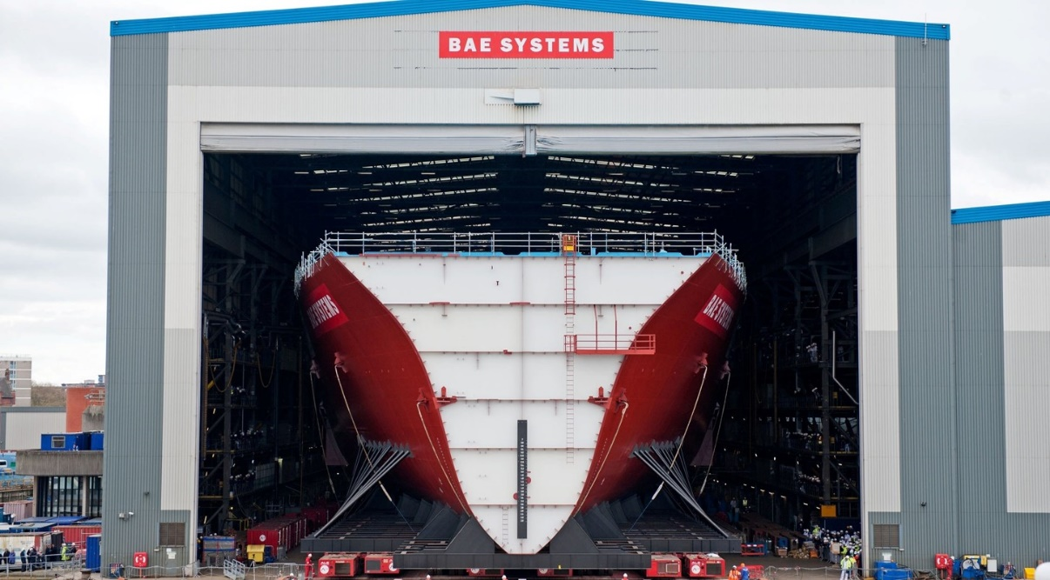

Mine Doors
Designed to withstand a high degree of mechanical stress and operating frequency, mine doors face tough conditions with many opening cycles per day in a harsh and dirty environment. Their flawless functioning provides safe access and protection to the huge trucks serving the mining industry, workers, and the equipment inside the mine. NIHVA has a robust solution to fulfil such requirements.
Mine doors come in vertical lifting Megadoor Fabric, tough and resilient in nature. The fabric is thermally insulating, which prevents the men and equipment inside the mines from the harsh outer environment, be it freezing snow or hot desert.

Features Of Mine Doors
- CORROSION-RESISTANT MATERIAL
- CAN SUSTAIN HARSH ENVIRONMENT
- PROVIDES HIGH-ENERGY EFFICIENCY
- IDEAL FOR LARGE OPENINGS
- TRANSLUCENT MEGADOOR FABRIC FOR DAYLIGHT UTILIZATION
- NO-TRACK SYSTEM – NO FLOOR TRACKS
- MULTI-LEAF DOORS FOR MASSIVE OPENING WIDTHS.

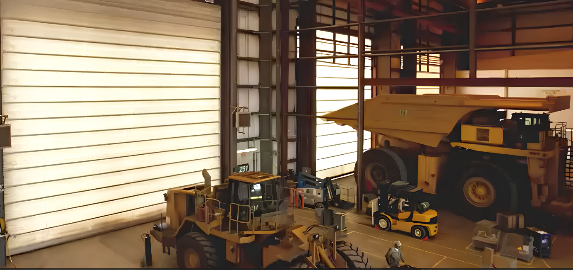

Crane Doors
In an industry having overhead cranes, it is very crucial to maintain the gateway regulations while giving proper access to the movement of the crane and allied goods. Crane doors can seal tightly around the crane while allowing free movement of objects. It is designed around the existing crane to ensure fast, reliable operations with high energy efficiency and also includes T-shape to adapt the crane to rails and multiple leaves.
The crane doors can be multiple leaf doors, giving a 100% sealing around the crane. Specially used near ports and logistic centres, crane doors provide protection to mechanical components of cranes and other assets on the site.

Features Of Crane Doors
- CORROSION-RESISTANT MATERIAL
- CAN SUSTAIN HARSH ENVIRONMENT
- PROVIDES HIGH-ENERGY EFFICIENCY
- IDEAL FOR LARGE OPENINGS
- TRANSLUCENT MEGADOOR FABRIC FOR DAYLIGHT UTILIZATION
- NO-TRACK SYSTEM – NO FLOOR TRACKS
- MULTI-LEAF DOORS FOR MASSIVE OPENING WIDTHS.

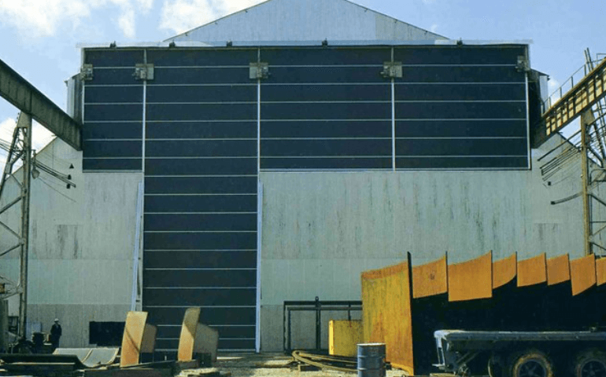

Sliding Glass Doors
The beauty of Automatic Sliding Glass Doors is in their smooth functioning and sleek looks. Completely noiseless, smooth, and quick operation, combined with the state-of-the-art tempered glass, Automatic Glass Doors are the perfect solution for shopping malls, hospitals, commercial and industrial areas and residential building entrance areas.
These Automatic Glass Doors designed with the latest technology are available in transparent and semi-transparent glass structures and are well suited for the secondary entrance requirements. Automatic glass sliding doors are available in a biparting or single sliding door system. The biparting system is used when the amount of clear opening required is more and the parking space available for glass pane is less. Available with a wide range of instrumentation and access control options, these doors provide a balanced mix of functionality and security. The installation and customization of the doors can be customized to be either wall-mounted or beam-mounted.
Features Of Sliding Glass Door
- 6 To 8mm Thick Glass
- Imported Operator – German Make
- Mechanical Lock
- Resistance Against Wind Draft
- Quick Opening
- Radar-Based Operation
- Break-Out / Reverse Break-Out Option

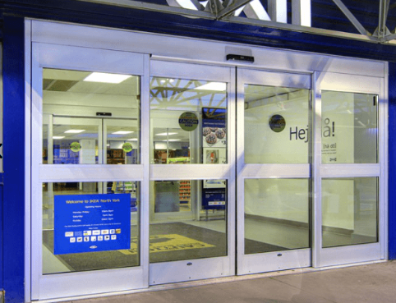

Revolving Glass Doors
The perfect solution for entrance requirements of hotels and commercial places, NIHVA Technologies is the best in the industrial & manufacturing sector and provides Automatic Revolving Glass Doors. The revolving glass doors are ideal for applications where a high amount of air infiltration is not desired. These include applications where air conditioning has to be maintained, such as the lobbies of hotels.
Providing moderate control over pedestrian traffic, Automatic Revolving Glass Doors are designed with the latest technology and can handle heavy traffic and high operating cycles.
The revolving doors are available in a wide variety of configurations, with or without glazing in two, three, or four-winged models. The architectural flexibility offered by Revolving Doors is unparalleled.
Features Of Revolving Glass Doors
- Imported Operator – German Make
- Smooth Operation
- Resistance Against Wind Draft
- Quick Opening
- Radar-Based Operation
- Motorized Operation
- High Aesthetic Value

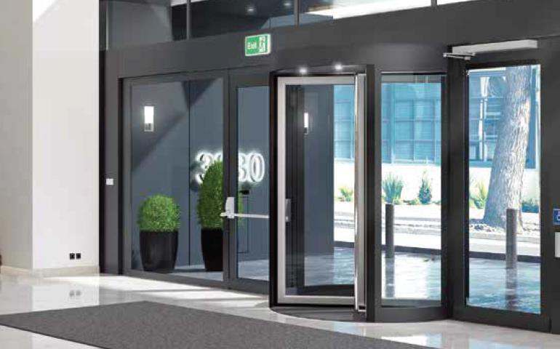

Swing Glass Doors
An ideal solution for residential and commercial entrances, Automatic Swing Doors or Swing Glass Doors provides the user an unparalleled gateway experience. Swing Doors utilize minimum space and provide a maximum clear opening. The door operators feature multiple designs, providing 90° or 180° openings. NIHVA Technologies delivers doors best in the manufacturing sector designed with the latest technology, and also provides the installation support. Specifically designed for sustainability, these high-quality automatic swing door operators are ‘Automatically Green’ certified. This helps in achieving the eco-friendly construction targets and restricting the carbon footprint of the organization
Swing doors use minimum space while maximizing the width of the opening. They provide an aesthetically pleasing doorway solution without compromising performance. Available with various safety and security measures, these doors provide safe and secure access, safeguarding your staff and goods. These automatic swing doors are relatively simple, yet highly sustainable ways to enhance the performance, accessibility and capacity of an entrance or exit point.

Features Of Swing Glass Door
- Imported Operator – German Make
- Smooth Operation
- Resistance Against Wind Draft
- Quick Opening
- Radar-Based Operation

Hermetically Sealed Doors
The industrial Hermetically Sealed door is specially designed for use in cleanroom environments in hospitals, laboratories and other facilities where demands on hygiene and infection control are high. NIHVA provides the best doors in the manufacturing sector designed using high-quality raw material and the latest technology.
Designed to restrict air infiltration and climate contamination, hermetically sealed doors by NIHVA Technologies provide installation service and a reliable infrastructure for patient logistics and surgical procedures in the operation theatres.
The door is designed wide enough for easy movement of the patient and allied infrastructure in and out of the room. As part of instrumentation and control, various access control systems are implemented, including mechanical, electrical locks, key card access and other systems to restrict unauthorized and accidental access to the room. Vision panels are available on demand. The door operator is designed to handle the high operating frequency and speed, essential for a busy hospital.
Our engineering and technical team at NIHVA Technology provide the best & reliable solutions such as Hermetically Sealed Doors by ASSA ABLOY. These doors also feature an emergency power supply in the form of UPS and a battery pack. This ensures continuous operation in case of power failure in the critical application of healthcare and research. Hermetically Sealed Doors of NIHVA Technologies find application in Hospital Operation theatres as Operation Theatre Door, in sensitive areas such as calibration labs or pathology labs, etc.

Features Of Swing Glass Door
- Rubber Edge For Airtight Sealing
- Fast Opening And Closing
- Radar-Based Operation
- Specialized Power Source For Operation During Power Failure
- Access Control Instrumentation
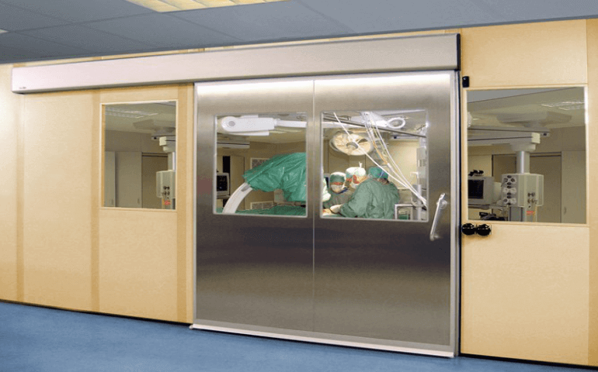

Fire Rated Rolling Shutter
Industrial Fire rated rolling shutters are widely used in sensitive areas such as boiler room, battery room, etc. areas that have high fire risk. Fire Rated Rolling Shutters function the same way Motorized Rolling Shutter does, the difference is the material used and the filling.
NIHVA offers the best industrial doors and rolling shutters in the manufacturing sector designed using high-quality raw material and the latest technology. Fire rated rolling shutters close automatically on fire detection, and prevent the spread of fire and smoke from the affected area.
These shutters are usually double skin by construction. Rockwool or other fire-retardant material is used as in-fill between two layers. The curtain is made up of fire rated Steel, which is designed to withstand the fire for up to 120 mi
The shutter has a fusible integrated link that melts on incidents of fire. This action triggers the shutter to close automatically in the event of fire.
Features Of Fire Rated Rolling Shutterss
- Fire Rated Upto 120 Mins.
- Reusable InHigher Fire Ratings Can Be Provided On Special Client Demand Temporary Installations
- Automatic Fusible Link For Automatic Closing In Case Of Fire
- Tested As Per BS 476 Part 22 And MS 1073 Part 3 1988
- Automatic Operation, Motorized
- Manual Operation Available – By Chain Drive
- Smoke Gaskets And Fire-Resistant Sealing To Prevent Fire And Smoke Leakage
- Can Be Integrated With Fire Alarm And Emergency Response Unit
- Constructed With Fire Rated Galvanized Steel

Fire Curtains
Fire Curtain is vital equipment in commercial and industrial establishments. A fire curtain is a curtain made from specially designed fireresistant material which is lowered in the event of a fire. When fire breaks out the fire curtain is lowered using the motorized actuators. The fire curtain forms an essential barrier between the fire and other property reducing damage and avoiding fire and smoke spread. The fire curtain is the best equipment for compartmentalizing the building isolating the hazardous and high risk areas. NIHVA Technologies we provide fire curtains for multiple applications in commercial and industrial establishments.
Fire Curtains represent a critical component in modern fire safety and building design. These innovative systems provide a reliable and efficient means of containing and controlling fires, thereby safeguarding lives and property. With their ability to compartmentalize spaces, prevent the spread of flames and smoke, and offer temporary escape routes, fire curtains play a pivotal role in minimizing the devastating consequences of fires.

Fire Rated Sliding Doors
Our industrial Fire Rated Sliding Doors find application in various residential, commercial and industrial areas associated with fire hazards. Fire Rated Sliding doors are used where, in case of fire, there is a need to contain the fire and smoke till emergency actions are taken. We see these doors being frequently used in elevator rooms in buildings, compressor rooms, central control rooms, networking centers and in factories.NIHVA offers the best industrial doors aFire rated sliding doors are usually bi-layer doors, i.e., the door leaf has two layers. Fire retardant material such as Glasswool or Rockwool is filled between these layers for fire resistance. The door leaf is usually made of Galvanized Iron while the gaskets are made from a special type of fire-retardant polymer.
Features Of Fire Rated Sliding Doors By NIHVA
- Fire Rated Upto 120 Mins.
- Fusible Link For Automatic Closure
- Insulating Material – Rockwool
- Sliding Operation – Manual And Automatic
- Specialized Gaskets For Preventing The Fire And Smoke Leakage
- Can Be Integrated With Emergency Systems, To Detect The Fire And Raise The Alarm
- Up To 1.2mm Thick GI Sheet Used As Door Leaf
- Available In Variety Of Paint Options

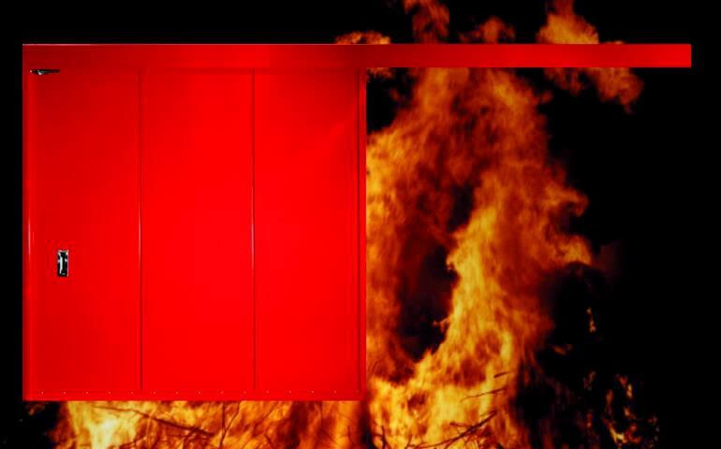

Entrance Gates
Automatic Sliding Gate & Door
Automatic Sliding Door ensure a completely safe environment with electrical locks, Commands available at any time to stop while the Gate moves, Other safety features guarantee highest safety standards Gate
Electric automatic sliding gate and doors ensure a completely safe environment with electrical locks, Commands available at any time to stop while the Gate moves, other safety features guarantee highest safety standards Gate
Features of Sliding Gate & Door
- Smooth Safe & Economical Operation.
- Varied Lengths of Gates Can Be Fabricated from 1000mm - 12000mm.
- Can Be Fabricated For Gates up to 18000 Kgs Weights Capacity
- Bottom Roller With High Precision Bearings
- Specialized Gaskets For Preventing The Fire And Smoke Leakage
- Can Be Integrated With Emergency Systems, To Detect The Fire And Raise The Alarm
- Up To 1.2mm Thick GI Sheet Used As Door Leaf

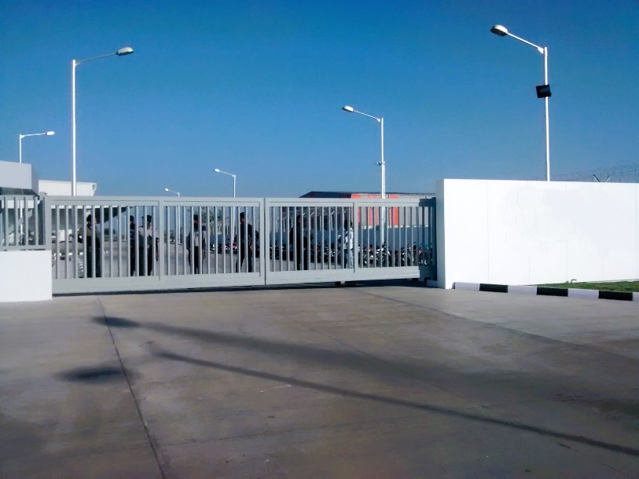

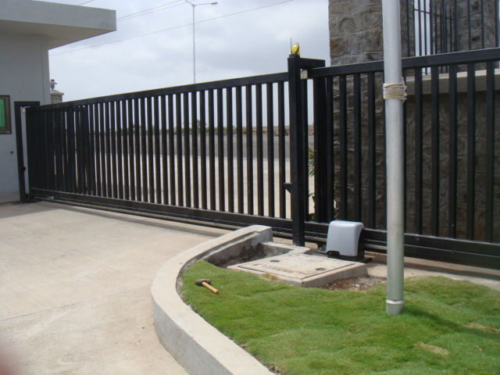

Telescopic Gates
In situations where a single side sliding arrangement to install the conventional sliding gates is not possible due to very less or no run-back space available, Telescopic sliding gate system proves to be the perfect solution.
Designed with multiple panels / leaves operating in telescopic fashion, they require very low run-back space and are highly space-efficient. Using the multi-actuator system, multiple leaves can be made to move simultaneously, greatly increasing the speed of operation of the gate. Each leaf of the telescopic gate can be made to move at a different speed so that the final position could be reached simultaneously, thanks to the specially designed telescopic mechanism. The telescopic gates are manufactured as per specific site requirements; they are suitable for medium to heavy-duty applications, and especially for very large openings.
Features Of Telescopic Gates
- Widely Used Where There Is Space Constraints For Sliding Gate Alongside The Boundary Wall Or Limited Space For Run Back.
- Also Suitable For Very Large Entrances.
- Can Be Telescopic Gates Manufactured In Two Or Three Gate Leaves Which Makes Possible To Achieve Larger Clear Opening. Fabricated For Gates Up to 18000 Kgs Weights Capacity
- Two Or Three Bottom Rails Are Required Depending On Clear Width Requirement.
- High Precision Sprocket & Chain Mechanism, Guide Rollers , Bottom Rollers , Limit Switch Ensures Smooth & Safe Operation Of Gate.
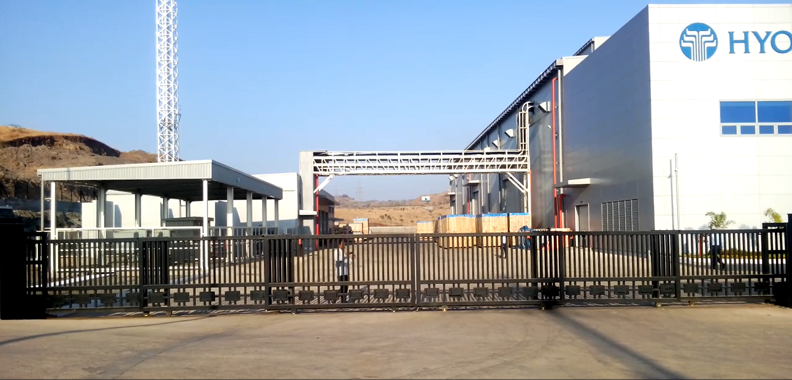

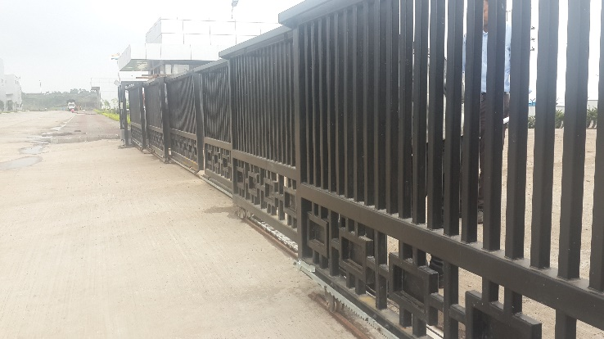

Cantilever Gates
At NIHVA Technologies, we provide improvised solution called automated cantilever sliding gates, which is a new value-added product in the range of standard sliding gates. Cantilever sliding gates have better operation, working and aesthetic appeal due to modern technology and improved reverse motion system. These gates have been introduced with the aim of overcoming the shortcomings of standard sliding gates and growing in terms of new trends and modern technology. Made from imported monolithic cantilever track and pair of heavy-duty bottom carriages, our cantilever sliding gates are supported on one end only, free without roadway tracks and are supported by sliding rollers in the tubular track at the bottom of the gate.
Supported on one end and the bottom edge being an inch above the ground level, these gates are the perfect solution where the roadways are uneven or it is not possible to lay the foundation for tracks and channels. Our automatic sliding Cantilever doors are virtually maintenance-free as there is no accumulation of dust and water on the track.

Features Of Cantilever Gates
- Noise-Free Movement Of Gate.
- No Track Or Concrete Foundation Required On The Roadway.
- Obstacle Free Entry Without Any Bumps.
- No Risk Of Non-Functioning Of Gate Due To Bending Or Wearing-Tearing Of Bottom Rail.
- Can Be Easily Installed On Uneven Or Sloped Ground Surface.
- Imported Monolithic Cantilever Track & Pair Of Heavy Duty Bottom Carriages.
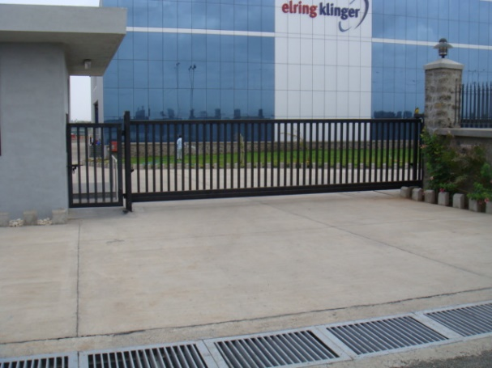

Swing Gates
At NIHVA, we make Swing gates for Spaces where driveway access is critical These are probably the most popular & widely used type of gates since they are most versatile and are very functional. Gates can be designed to swing inwards or outwards.
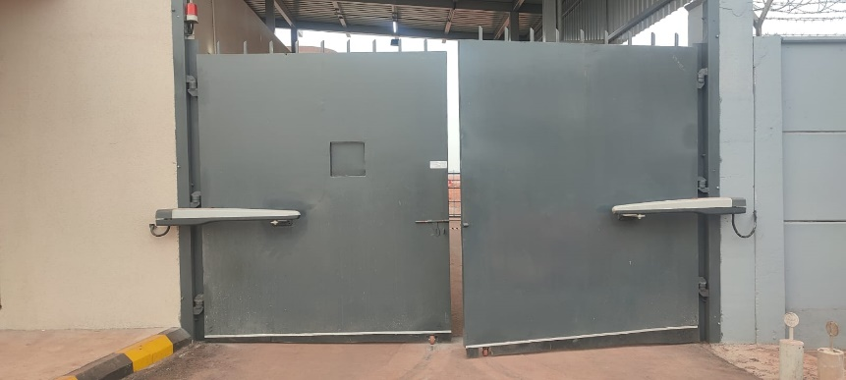
We manufacture a vast range of automatic swing gates in different compact designs & configurations that are extremely easy to install and maintain. These gates are provided with the self-locking electromechanical operator and are specifically designed to suit all architectural designs. Ideally, all of our automatic swing gates are set up on a structural metal frame, good quality pivots (hinges) or wheels. The wheels may be designed in the fashion which needs the client to lay ground tracks or channels as guides for the gate.

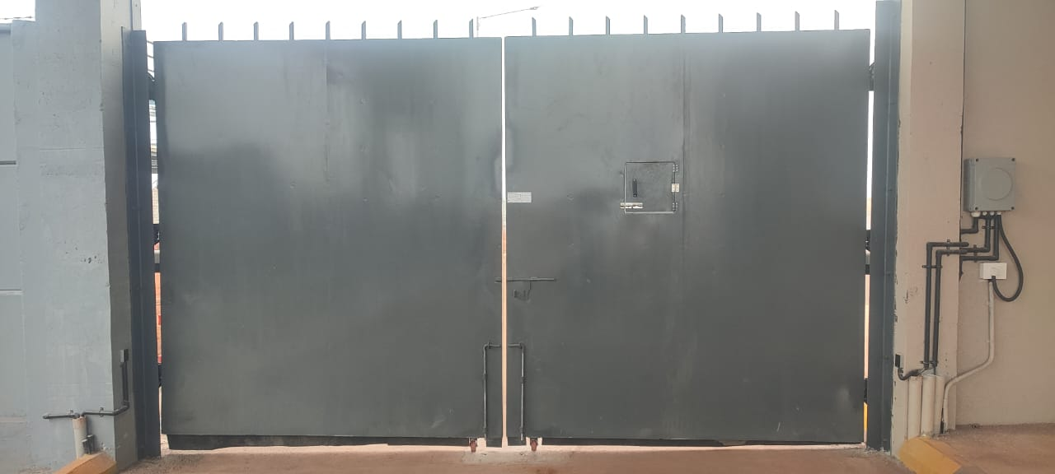

Rolling Shutters
Single Skin Rolling Shutters
NIHVA make manual rolling shutters are manufactured with high grade galvanized iron(GI),mild steel (SS) and aluminum(AL) using the latest technology to ensure high durability and low maintenance costs. the curtain panels are made of 1.0mm thick CRCA steel, with corrugated, flat or ribbed profile, securely held in place.
NIHVA make manual rolling shutters are assisted by counter balancing springs depending on the curtain wait. This rolling shutter are manufactured according to Indian standards norms, with customizable specification and competitive prices.

Double Skin Rolling Shutters
The insulated shutter from NIHVA is perfectly suitable the openings where aesthetic along with high security matters. As the name insulated rolling shutter, each slat is insulated with polyurethane foam, which helps to control temperature and noise
This shutter have high resistance to corrosion as the slats are constructed of per-coated galvanized shit with profile thickness of 19mm.
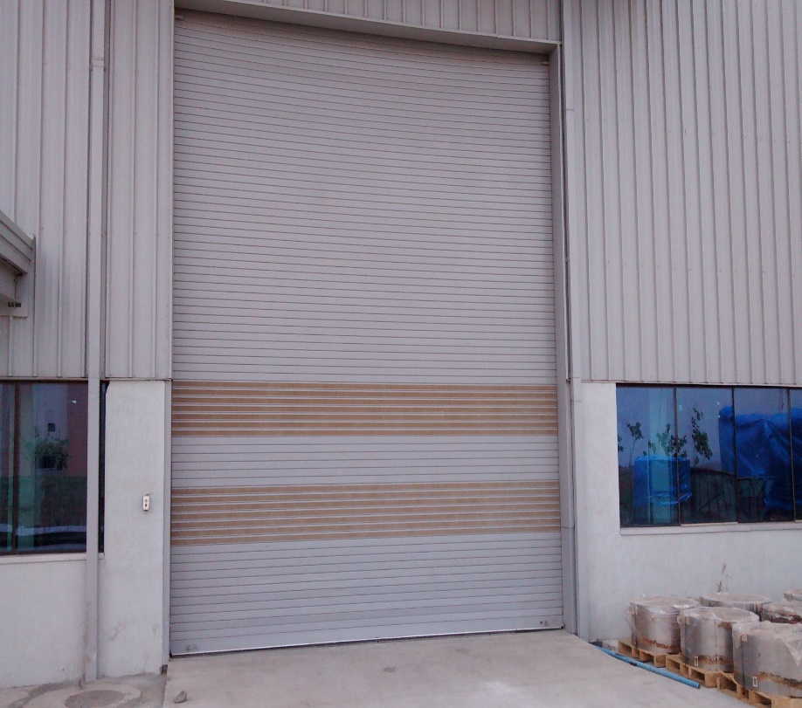

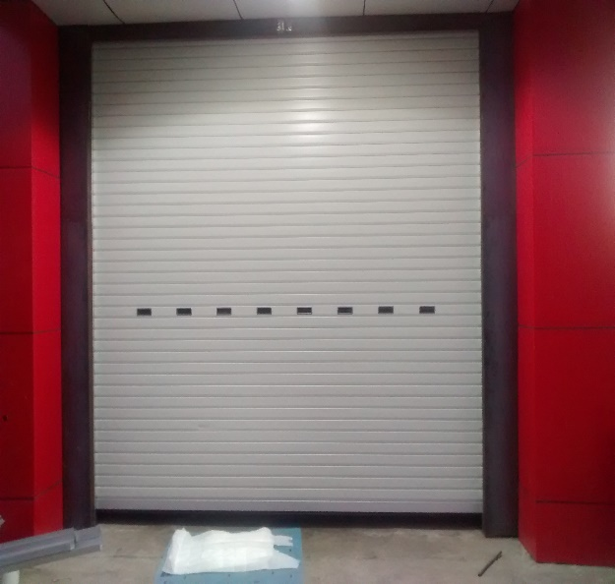

Dock Shelter & Dock Leveller
Swing Dock Shelter
Hydraulic Swing-lip Dock Levelers provide safe and efficient loading & unloading and minimize downtime. The result provides high safety for goods transfer and prevents any damage to equipment. Swing lip dock leveler has a swing lip that bridges the gap between building and vehicle. This equipment connect the loading bay to the vehicle bed, making access for forklift or other material handling equipment to reach inside the truck. This reduces labour cost and logistic and material handling efforts.
Telescopic Dock Levelers
Dock leveller can be precisely mounted on the vehicle bed to enable optimal loading and better safety.
Features Of Dock Leveller
- Effective Device For Loading – Unloading Cargo
- Ideal For Warehouses And Logistic Facilities
- Swing Type And Telescopic Type
- Suitable With Wide Dimensions Of Truck Beds
- Capacity Upto 6 T


